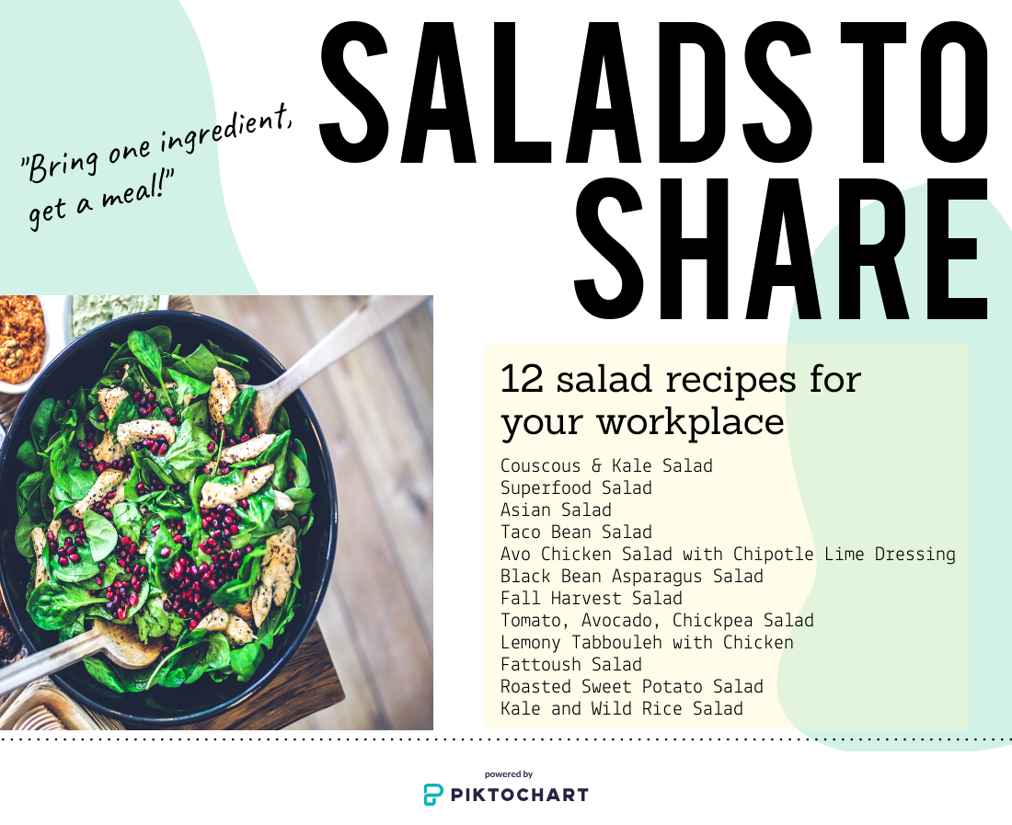
Are you and your co-workers ready for some amazing lunches?
For a successful Salad Day, you will need a Coordinator to keep things running smoothly. Here’s how it works:
- The 12 recipes in this book have been formatted as sign-up sheets for a potluck style lunch for several people to participate. Each person who signs up will have to bring ingredients from the list! If you have more people than the number of ingredients listed, you can split up some of the items or coordinate two bowls of salad. If you have less people than ingredients, double up!
- Decide which day is going to be Salad Day! A Thursday or Friday works best to give participants enough time to sign up.

- Pick a new recipe each week to keep it interesting, and copy and paste the sign-up from this document into a new document.

- Distribute the sign-up sheet for the chosen salad early in the week, ideally Monday or Tuesday. Participants will sign up by writing their name in the “Person” column. This can either be done one of two ways:
  - Electronically as a Word document (if there is a common place where the sign-up can be saved and multiple participants can edit the Word document).
  - Print out the sheet and have participants sign up manually.
- Have a large bowl set out the morning of Salad Day. You will also need tongs for mixing and serving.

- Have a printed off sign-up sheet present near the salad bowl on Salad Day. Participants should cross off their name in the “Person” column once they add their ingredient to the bowl. Toss the salad once all ingredients have been added to the bowl.

- Division of the salad can be done either one of two ways:
  - Once the salad has been tossed, cover the salad bowl and place in a fridge until lunch. At lunch, participants serve themselves and check the final column when they have taken their portion of salad.
  - Once the salad has been tossed, the coordinator divides the salad between the participant’s bowls or containers, then covers and places each individual bowl in the fridge. Each participant can then take their individual serving at lunch time. This can help ensure everyone gets an equal portion of salad.
- Participants should bring their own bowl and fork (unless your workplace has them available) and clean their own dishes.
Salad Days: Date Couscous & Kale Salad
Add all ingredients into a large bowl leaving almonds on the side. Toss to combine. Chill until ready to serve. Top with slivered almonds.
Ingredient and Amount | Person | Salad Taken (√)
2 cups dry couscous, cooked according to package directions
1 bunch kale, chopped
1 cup dried cranberries
2 yellow peppers, diced
¾ cup slivered almonds (leave on side in case of allergies)
1/2 cup feta cheese, crumbled
Dressing: ½ cup olive oil, 5 tbsp balsamic vinegar, ¾ tsp salt, pinch black pepper

Please have all ingredients to the [fill in location of salad bowl] by 9:00 a.m. so
the salad can be mixed and chilled.
Come to the [location] at noon to get your salad! Bring a fork!

Salad Days: Date Superfood Salad
Add dressing ingredients into a small bowl/jar and whisk together. Add all other ingredients into a large bowl. Chill until ready to serve. Cover with dressing and toss to combine.
Ingredient and Amount | Person | Salad Taken (√)
2 cups dry quinoa, cooked according to package directions
2 cups frozen edamame, cooked according to package directions
2 bunches curly kale torn into bite-sized pieces
2 cups dried cherries or cranberries, 1 cup sunflower seeds
2 cups fresh blueberries, 1 cup chopped walnuts (leave nuts on side)
2 cups red grapes, halved; 1 cup crumbled feta or goat cheese
Dressing: 1 cup orange juice, ½ cup olive oil, 4 cloves minced garlic, 4 tsp sugar, 2 tsp salt, 1 tsp pepper, 1/3 cup plain Greek yogurt

Please have all ingredients to the [fill in location of salad bowl] by 9:00 a.m. so
the salad can be mixed and chilled.
Come to the [location] at noon to get your salad! Bring a fork!

Salad Days: Date Asian Salad
Add dressing ingredients into a small bowl/jar and whisk together. Add all other ingredients into a large bowl. Cover with dressing and toss to combine. Chill until ready to serve.
Ingredient and Amount | Person | Salad Taken (√)
4 large carrots, grated

3 large red peppers, finely diced

4 celery stalks, finely diced

1 medium red onion, finely diced

1 cup parsley, chopped

½ cup toasted sesame seeds
Dressing: 3 tbsp lemon juice; 3 tbsp honey; 4 tsp soy sauce; 4 tbsp sesame oil; 3 tsp ginger, grated; 3 cloves garlic, grated

Please have all ingredients to the [fill in location of salad bowl] by 9:00 a.m. so
the salad can be mixed and chilled.
Come to the [location] at noon to get your salad! Bring a fork!

Salad Days: Date Taco Bean Salad
Add dressing ingredients into a small bowl/jar and whisk together. Add all other ingredients into a large bowl (except tortilla chips) and toss to combine. Chill until ready to serve. Top with tortilla chips and enjoy!
Ingredient and Amount | Person | Salad Taken (√)
8 cups romaine lettuce, chopped
2- 19 oz. cans red kidney beans, rinsed and drained
1 cup red onion, finely chopped
1 cup tomatoes, chopped
3 avocados, chopped
4 cups corn tortilla chips, crushed
Dressing: ½ cup sour cream, ½ cup Catalina dressing; 4 Tbsp fresh parsley, chopped, ½ tsp ground cumin, 2 cloves garlic minced (optional: 1 Tbsp sliced pickled jalapeno)

Please have all ingredients to the [fill in location of salad bowl] by 9:00 a.m. so
the salad can be mixed and chilled.
Come to the [location] at noon to get your salad! Bring a fork!

Salad Days: Date Avocado Chicken Salad with Chipotle Lime Dressing
Add dressing ingredients into a blender and pulse until combined together. Add all other ingredients into a large bowl. Chill until ready to serve. Cover with dressing and toss to combine.
Ingredient and Amount | Person | Salad Taken (√)
2 lb boneless, skinless chicken breasts, grilled, cooled and diced
2 packages cherry tomatoes, halved
4 medium avocadoes, diced
3 cups cooked corn
2 head romaine lettuce
1 cup crumbled feta cheese
Dressing Part 1: 2 cups plain Greek yogurt, ½ cup mayo, ½ cup buttermilk, 4 Tbsp lime juice
Dressing Part 2: 3 chipotle chili peppers in adobo, 2 cloves garlic, 4 tsp dried parsley, 1 tsp onion powder, 1 tsp dried dill, 1 tsp chives, ½ tsp paprika

Please have all ingredients to the [fill in location of salad bowl] by 9:00 a.m. so
the salad can be mixed and chilled.
Come to the [location] at noon to get your salad! Bring a fork!

Salad Days: Date Black Bean Asparagus Salad
Add all ingredients into a large bowl. Whisk together dressing ingredients and add to bowl. Toss to combine. Chill until ready to serve (at least 2 hours).
Ingredient and Amount | Person | Salad Taken (√)
1 pound fresh asparagus, trimmed and cut into 1-inch pieces, cooked (see below)
1 pound fresh asparagus, trimmed and cut into 1-inch pieces, cooked (see below)
2 cans black beans, rinsed and drained
1 large red pepper, chopped
1 medium sweet onion, chopped, ¾ cup minced fresh parsley
Dressing: ¼ cup olive oil, 2 Tbsp lime juice, 1/8 tsp salt, 1/8 tsp pepper

Please have all ingredients to the [fill in location of salad bowl] by 9:00 a.m. so
the salad can be mixed and chilled.
Come to the [location] at noon to get your salad! Bring a fork!

* To cook asparagus, bring asparagus pieces and 2 cups of water to boil in a pot. Reduce heat, cover and simmer 4-5 minutes until tender-crisp. Rinse in cold water and pat dry.

Salad Days: Date Fall Harvest Salad
Add salad ingredients into a large bowl and toss to combine. Mix dressing ingredients in a separate bowl/ jar. Chill until ready to serve. Top with dressing and serve.
Ingredient and Amount | Person | Salad Taken (√)
½ cup uncooked wild rice, cooked according to package directions
4 cups butternut squash cut in ½ inch cubes **see cooking instructions below
5 cups kale, cut in bite-sized pieces
2 apples, cut in ½ inch cubes
¾ cup dried cranberries, ½ cup toasted pepitas (likely have to buy raw ones and toast in a pan)
Dressing: 2 Tbsp apple juice, 2 Tbsp apple cider vinegar, ¼ cup olive oil, 1 tsp Dijon mustard, ½ tsp salt, ½ tsp pepper, ½ tsp garlic powder

Please have all ingredients to the [fill in location of salad bowl] by 9:00 a.m. so
the salad can be mixed and chilled.
Come to the [location] at noon to get your salad! Bring a fork!

** To cook butternut squash, preheat oven to 375ºF. Line a baking sheet with parchment paper or foil. Toss squash pieces in 1 Tbsp olive oil, salt and pepper. Spread in an even layer and bake ~ 15 minutes until squash is cooked through.

Salad Days: Date Tomato, Avocado, Cucumber, Chickpea Salad
Add dressing ingredients into a small bowl/jar and whisk together. Add all other ingredients into a large bowl, cover with dressing and toss to combine. Chill until ready to serve.
Ingredient and Amount | Person | Salad Taken (√)
2 packages red cherry tomatoes, halved
1 package yellow cherry tomatoes, halved
1 large can chickpeas, drained and rinsed; 1 tbsp fresh basil, minced
1 large cucumber, diced; ¼ cup fresh parsley, minced
2 avocados, diced
¾ cup crumbled feta cheese
Dressing: 1 tsp Dijon mustard, ¼ cup lemon juice, ¼ tsp salt, ½ cup olive oil, ¾ tsp dried oregano, 2 cloves minced garlic

Please have all ingredients to the [fill in location of salad bowl] by 9:00 a.m. so
the salad can be mixed and chilled.
Come to the [location] at noon to get your salad! Bring a fork!

Salad Days: Date Lemony Tabbouleh with Chicken
Add salad ingredients into a large bowl and toss to combine. Mix dressing ingredients in a separate bowl/ jar. Chill until ready to serve. Top with dressing and serve.
Ingredient and Amount | Person | Salad Taken (√)
1 cup uncooked bulgur wheat, cooked according to package directions
1 cup diced tomato (1 large); 1 cup cucumber sliced and quartered
1/3 cup chopped fresh parsley; ¼ cup sliced scallions (2); ¼ cup finely chopped fresh mint, 3 Tbsp toasted pine nuts
6 oz cooked boneless, skinless chicken breast, roughly chopped (2 breasts, from a rotisserie chicken is what the recipe suggests)
Dressing: 3 Tbsp olive oil, ½ tsp lemon zest, ¼ cup lemon juice, ½ tsp black pepper, ½ tsp salt

Please have all ingredients to the [fill in location of salad bowl] by 9:00 a.m. so
the salad can be mixed and chilled.
Come to the [location] at noon to get your salad! Bring a fork!

Salad Days: Date Fattoush Salad
Add dressing ingredients (shaded below) into a small bowl/ jar and whisk together. Add all other ingredients into a large bowl. Cover with dressing and toss to combine. Chill until ready to serve.
Ingredient and Amount | Person | Salad Taken (√)
2 heads romaine lettuce, chopped into bite sized pieces
2 English cucumbers, thinly sliced
½ red onion, thinly sliced
4 cups pita chips, homemade or store bought
1 package cherry tomatoes, cut into quarters
1 cup fresh mint leaves, coarsely chopped; 1 cup fresh flat leaf parsley (leaves only, no stems), coarsely chopped
Dressing: 2/3 cup olive oil, 1/3 cup lemon juice, 2 cloves minced garlic, 2 tsp salt, 2 tsp sumac (if you don’t have/ can’t find sumac substitute with 2 tsp lemon zest mixed with a pinch of salt), 2 tsp honey

Please have all ingredients to the [fill in location of salad bowl] by 9:00 a.m. so
the salad can be mixed and chilled.
Come to the [location] at noon to get your salad! Bring a fork!

Salad Days: Date Roasted Sweet Potato Salad
Add dressing ingredients into a small bowl/jar and whisk together. Add all other ingredients into a large bowl. Pour dressing over salad and toss to combine. Chill covered in the fridge until lunch.
Ingredient and Amount | Person | Salad Taken (√)
1 large sweet potato, peeled, cut into 1 inch pieces, roasted **
1 large sweet potato, peeled, cut into 1 inch pieces, roasted **
1 15oz can black beans, drained and rinsed
4 green onions, thinly sliced; ½ cup cilantro, minced
2 red peppers, diced
1.5 cups cooked corn
Dressing: 3 Tbsp honey, 3 Tbsp Dijon mustard, 3 Tbsp lemon or lime juice, 3 Tbsp olive oil, ½ tsp salt, ½ tsp pepper, pinch cayenne pepper

Please have all ingredients to the [fill in location of salad bowl] by 9:00 a.m. so
the salad can be mixed and chilled.
Come to the [location] at noon to get your salad! Bring a fork!
** To roast sweet potatoes, peel and chop into 1 inch pieces. Toss potatoes with 2 Tbsp olive oil, ½ tsp salt and ½ tsp pepper. Spread evenly on a baking sheet sprayed with cooking spray. Bake for 30-45 minutes at 400ºF until able to pierce with a fork. Flip once halfway through.

Salad Days: Date Kale and Wild Rice Salad
Add dressing ingredients into a small bowl/jar and whisk together. Add all other ingredients into a large bowl. Chill until ready to serve. Cover with dressing and toss to combine.
Ingredient and Amount | Person | Salad Taken (√)
4 cups cooked wild rice blend, cooled
3 cups kale, chopped (~ 1 bunch)
2 apples, diced; 2 oranges, diced
½ cup dried cranberries; ¼ cup dried tart cherries
3 stalks celery, diced; 2 green onions, thinly sliced
Dressing: ¼ cup minced shallot, 1 Tbsp olive oil, 3 tbsp water, 2 Tbsp sugar, 1 Tbsp apple cider vinegar, 2 Tbsp orange juice, 1 tsp Dijon mustard, ½ tsp salt, 1/8 tsp pepper

Please have all ingredients to the [fill in location of salad bowl] by 9:00 a.m. so
the salad can be mixed and chilled.
Come to the [location] at noon to get your salad! Bring a fork!

