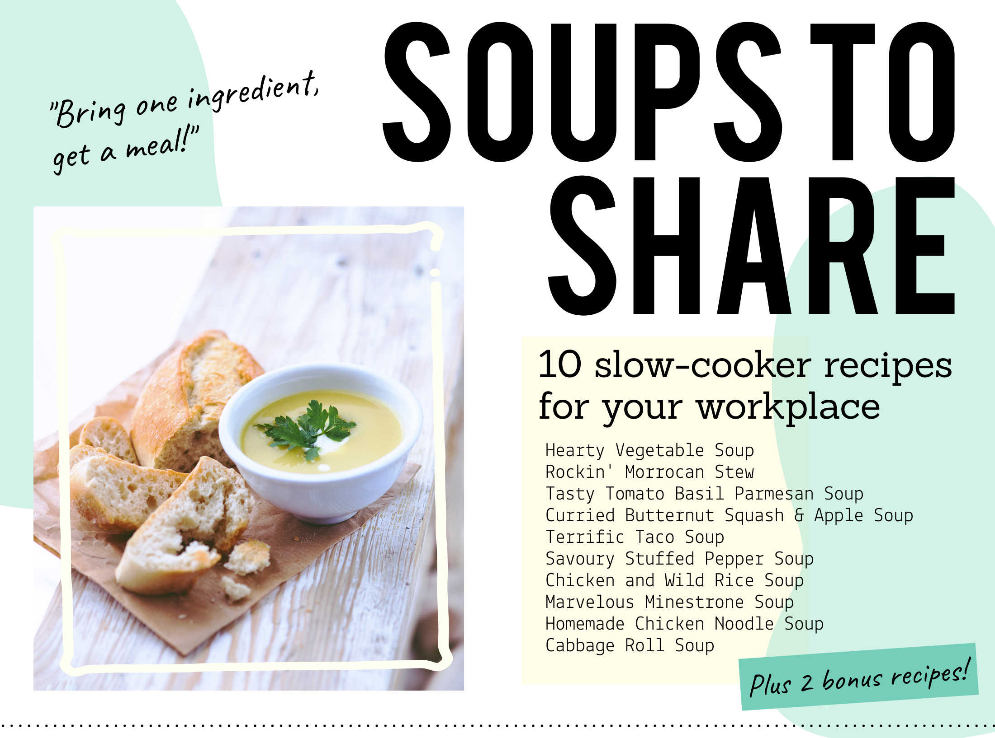

Are you and your co-workers ready for some amazing lunches?
For a successful Soup Day, you will need a Coordinator to keep things running smoothly.
Here’s how it works:
- The 10 recipes (and 2 bonus recipes) in this book have been formatted as sign-up sheets for a potluck style lunch for up to 7 people. Each person who signs up will have to bring ingredients from the list! If you have more than 7 people who would like to participate, you can split up some of the items. If you have less than 7 people, double up!
- Decide which day is going to be Soup Day! A Thursday or Friday works best to give participants enough time to sign up.

- Pick a new recipe each week to keep it interesting, and copy and paste the sign-up from this document into a new document.

- Distribute the sign-up sheet for the chosen soup early in the week, ideally Monday or Tuesday. Participants will sign up by writing their name in the “Person” column. This can either be done one of two ways:
  - Electronically as a Word document (if there is a common place where the sign-up can be saved and multiple participants can edit the Word document).
  - Print out the sheet and have participants sign up manually.
- Have the crock pot set up and turned to HIGH the morning of Soup Day. You will need a ladle for mixing and serving.
  - For some recipes, note that some ingredients are added later.
  - Some recipes require an immersion blender for the best effect.
  - Remind participants to cut veggies very small (or precook them) to cook in time for lunch.
- Have a printed off sign-up sheet present near the crock pot on Soup Day. Participants should cross off their name in the “Person” column once they add their ingredient, and check the final column when they have taken soup.
- Participants should bring their own bowl and spoon (unless your workplace has them available) and clean their own dishes.
- The participant who signs up for “Buns and Cleanup” is responsible for cleaning the crock pot and surrounding area once everyone has collected their soup.
Soup Days: Date Hearty Vegetable Soup
(add water as needed)
Ingredients and Amounts | Person | Soup Taken (√)
2 onions, diced small and precooked; 4 cloves of garlic, minced;
2 cups celery, chopped small
2 cups carrots, chopped small
2 small potatoes, peeled and chopped small
2 green peppers, chopped small
2 cans (28 oz) diced tomatoes, 1 can (19 oz) chick peas, drained and rinsed
1 tsp dried oregano, ½ tsp cumin, ½ tsp hot pepper flakes,
2 bay leaves, 2 tsp paprika
1 dozen whole wheat buns; Clean up

Please have all ingredients to the [fill in location of crockpot] by 9:00 a.m. so the soup can get cooking!
Try to chop all vegetables quite small so they will be soft by lunch.

Come to the [location] at noon to get your soup! Bring a bowl and a spoon!
The person who signed up for cleanup will wash the crockpot once everyone has collected their soup.
Soup Days: Date Rockin’ Morrocan Stew
Ingredients and Amounts | Person | Soup Taken (√)
1 cup onions, diced small and precooked; ½ cup celery, diced small; ½ cup green pepper, diced small
3 cups peeled and cubed sweet potato (small cubes!)
1 can (28 oz) diced tomatoes; 1 can (19 oz) chickpeas, drained and rinsed
2 cups chopped kale, 2 Tbsp seed or peanut butter
2 Tbsp fresh cilantro (hold for garnish)
3 cups vegetable broth, ½ cup light coconut milk
1 tsp minced garlic, 2 tsp grated gingerroot, 1 tsp each of ground cumin, curry powder, ground coriander, and chili powder,
1 Tbsp squeezed lemon juice, ½ tsp salt, ¼ tsp pepper
¼ cup of raisins, 1 dozen whole wheat buns or naan/pita bread;
Clean up

Please have all ingredients to the [fill in location of crockpot] by 9:00 a.m. so the soups can get cooking!
Try to chop all vegetables quite small so they will be soft by lunch.

Come to the [location] at noon to get your soup! Bring a bowl and a spoon!
The person who signed up for cleanup will wash the crockpot once everyone has collected their soup.

Soup Days: Date Tasty Tomato Basil Parmesan Soup
(blend with immersion blender at 11:30, then add milk, Parmesan cheese and pasta)
Ingredients and Amounts | Person | Soup Taken (√)
2 (28 oz) cans diced tomatoes; 2 tsp dried oregano, 3 Tbsp dried basil, 1 bay leaf, 1 tsp salt, ½ tsp pepper
1 cup finely diced celery; 1 cup finely diced carrots
1 cup finely diced onions, precooked
4 cups chicken broth; 2 cups milk (add milk at 11:30 after blending)
1 cup grated Parmesan cheese (add cheese at 11:30 after blending)
1 cup orzo pasta, cooked according to package directions
(add at 11:30 after blending)
1 dozen whole wheat buns; Clean up

Please have all ingredients to the [fill in location of crockpot] by 9:00 a.m. so the soups can get cooking!
Try to chop all vegetables quite small so they will be soft by lunch.

Come to the [location] at noon to get your soup! Bring a bowl and a spoon!
The person who signed up for cleanup will wash the crockpot once everyone has collected their soup.
Soup Days: Date Curried Butternut Squash & Apple Soup
(**blend with immersion blender before serving**)
Ingredients and Amounts | Person | Soup Taken (√)
2 cups onion, diced small; 1 celery stalk, diced small; 4 tsp curry powder (cook these ingredients in ½ cup margarine until soft – bring everything including extra margarine from pan to add to the soup)
1 medium butternut squash, peeled, seeded and diced in 1 cm pieces
1 medium butternut squash, peeled, seeded and diced in 1 cm pieces
2 medium apples, cored and diced in 1 cm pieces
1 medium apple, cored and diced in 1 cm pieces; 1 cup apple juice (add juice after soup has been blended; 11:30am)
3 cups vegetable stock; 1 tsp salt, ½ tsp pepper
1 dozen whole wheat buns; Clean up

Please have all ingredients to the [fill in location of crockpot] by 9:00 a.m. so the soups can get cooking! Try to chop all vegetables quite small so they will be soft by lunch.

Come to the [location] at noon to get your soup! Bring a bowl and a spoon!
The person who signed up for cleanup will wash the crockpot once everyone has collected their soup.
Soup Days: Date Terrific Taco Soup
(add 2 cups water)
Optional toppings: plain Greek yogurt, shredded cheese, tortilla chips, avocado, lime wedges.
Ingredients and Amounts | Person | Soup Taken (√)
1 lb ground beef or turkey, cooked and drained
1 onion, diced small and precooked; 1 (28oz) can diced tomatoes
2 bell peppers, diced small
1 small zucchini, diced small; 1 (15oz) can mixed beans
2 cups frozen corn or 1 (15oz) can; 1 (28oz) can diced tomatoes
Spices: 3 Tbsp homemade taco seasoning* (or 1 package);
3 Tbsp homemade Ranch seasoning** (or 1 package)
1 dozen whole wheat buns; Clean up

Please have all ingredients to the [fill in location of crockpot] by 9:00 a.m. so the soups can get cooking!
Try to chop all vegetables quite small so they will be soft by lunch.
Come to the [location] at noon to get your soup! Bring a bowl and a spoon!
The person who signed up for cleanup will wash the crockpot once everyone has collected their soup.
.
* Homemade Taco Seasoning Recipe
5 Tbsp chili powder
4 Tbsp ground cumin
1 tsp ground coriander
1 tsp onion powder
1 tsp garlic powder
1 tsp salt
½ tsp pepper
¼ tsp cayenne pepper
¼ tsp red pepper flakes (optional)

** Ranch Seasoning Recipe

1 tsp garlic powder
2 Tbsp parsley
½ tsp basil
1 tsp dill weed
1 tsp onion flakes
½ tsp pepper

Soup Days Date Savoury Stuffed Pepper Soup

Ingredients and Amounts | Person | Soup Taken (√)
1 lb extra lean ground beef, cooked
1 onion, diced small and precooked
1 can (28 oz) diced tomatoes with garlic and onions;
1 can (398 ml) tomato sauce
2 cups green and/or red peppers, chopped small
1 cup cooked rice (add at 11:00am)
1 carton beef broth; ½ tsp basil; ½ tsp oregano
1 dozen whole wheat buns; Clean up

Please have all ingredients to the [fill in location of crockpot] by 9:00 a.m. so the soups can get cooking!
Try to chop all vegetables quite small so they will be soft by lunch.

Come to the [location] at noon to get your soup! Bring a bowl and a spoon!
The person who signed up for cleanup will wash the crockpot once everyone has collected their soup.
Soup Days: Date Chicken and Wild Rice Soup
Ingredients and Amounts | Person | Soup Taken (√)
1½ lbs chicken, chopped and cooked
6 cups chicken broth
2 cups whole milk; ¼ cup white flour (add milk and flour at 11:30) **mix flour in a small amount of milk before adding
1 cup wild rice, uncooked
3 cloves minced garlic; 1 onion, diced and precooked;
1 lb mushrooms, thinly sliced
3 carrots, diced small; 3 stalks celery, diced small
½ tsp salt; ¼ tsp pepper; ½ tsp thyme; ½ tsp rosemary;
2 bay leaves
1 dozen whole wheat buns; Clean up

Please have all ingredients to the [fill in location of crockpot] by 9:00 a.m. so the soups can get cooking!
Try to chop all vegetables quite small so they will be soft by lunch.

Come to the [location] at noon to get your soup! Bring a bowl and a spoon!
The person who signed up for cleanup will wash the crockpot once everyone has collected their soup.

Soup Days: Date Marvelous Minestrone Soup
(**add 2 cups water**)
Ingredients and Amounts | Person | Soup Taken (√)
1 (28oz) can diced tomatoes; 2 Tbsp tomato paste;
¼ cup sun-dried tomato pesto
4 cups (1 carton) vegetable broth; 1 tsp dried oregano;
½ tsp dried rosemary; 2 bay leaves, ½ tsp salt, ¼ tsp pepper
1 cup carrots, peeled and diced small; 1¼ cup celery, diced small;
1½ cups zucchini, diced small
1½ cups onion, diced small and precooked; 2½ cups baby spinach, chopped (add spinach at 11:30am)
1 (15oz) can red kidney beans, drained and rinsed; 1 (15oz) can Great Northern beans, drained and rinsed; 5 cloves garlic, minced
1½ cups uncooked small pasta, cooked according to directions on package; 1 cup frozen green beans, thawed (add both at 11:30am)
1 dozen whole wheat buns; Clean up

Please have all ingredients to the [fill in location of crockpot] by 9:00 a.m. so the soups can get cooking!
Try to chop all vegetables quite small so they will be soft by lunch.

Come to the [location] at noon to get your soup! Bring a bowl and a spoon!
The person who signed up for cleanup will wash the crockpot once everyone has collected their soup.
Mug-a-Soup Days: Date Homemade Chicken Noodle Soup
(**add 1 cup water**)
Ingredients and Amounts | Person | Soup Taken (√)
1½ lbs boneless, skinless chicken breasts, cooked and chopped into bite sized pieces (rotisserie or precooked chicken breasts can be used)
1¾ cups carrots, peeled and chopped small;
1¼ cups celery, chopped small
1½ cups onion, chopped small and precooked;
4 cloves garlic, minced
6 cups chicken broth, 3 Tbsp olive oil, 1 Tbsp lemon juice
(add lemon juice at 11:30am)
¾ tsp dried thyme, ½ tsp crushed dried rosemary, ½ tsp dried sage, ¼ tsp crushed celery seed, 2 bay leaves, ½ tsp salt, ¼ tsp pepper; ¼ cup chopped fresh parsley (add parsley at 11:30am)
2 cups uncooked wide egg noodles, cooked according to package directions, add at 11:30am
1 dozen whole wheat buns; Clean up

Please have all ingredients to the [fill in location of crockpot] by 9:00 a.m. so the soups can get cooking! Try to chop all vegetables quite small so they will be soft by lunch.

Come to the [location] at noon to get your soup! Bring a bowl and a spoon!
The person who signed up for cleanup will wash the crockpot once everyone has collected their soup.
Soup Days: Date Cabbage Roll Soup
(**add 2 cups water**)
Ingredients and Amounts | Person | Soup Taken (√)
1½ lbs ground beef, 1 large onion chopped small,
3 cloves minced garlic; cooked together and drained
2 carrots finely chopped; 1 large can (680ml) tomato sauce
6 slices cooked bacon, chopped finely; 1 can (5.5 oz) tomato paste
2 (10oz) cans beef consommé; 1 can (28 oz) diced tomatoes
6 cups chopped green cabbage; ¾ cup long grain white rice
1 Tbsp Worcestershire sauce, 2 bay leaves,
2 Tbsp brown sugar, ½ tsp salt, ¼ tsp pepper
1 dozen whole wheat buns; Clean up

Please have all ingredients to the [fill in location of crockpot] by 9:00 a.m. so the soups can get cooking!
Try to chop all vegetables quite small so they will be soft by lunch.

Come to the [location] at noon to get your soup! Bring a bowl and a spoon!
The person who signed up for cleanup will wash the crockpot once everyone has collected their soup.
BONUS RECIPE: Slow-Cooker Chicken Fajitas
*Ask participants to sign up for toppings as well*
Date:
Ingredients and Amounts | Person | Soup Taken (√)
1 lb boneless, skinless chicken breast (sliced into thin strips)
1 lb boneless, skinless chicken breast (sliced into thin strips)
1 red and 1 green pepper, julienned
1 orange pepper and 1 large yellow onion, julienned
4 cloves garlic, minced; 2 ½ tsp chili powder; 2 tsp cumin;
1 tsp paprika; ¾ tsp ground coriander; 1 tsp salt; ¾ tsp pepper
1 can (540 ml) diced tomatoes (with green chilies if available)
2 Tbsp lime juice; 1 Tbsp honey (add these both just before serving)
1 large package whole wheat tortillas (8-10); Clean up

Please have all ingredients to the [fill in location of crockpot] by 9:00 a.m. so the filling can get cooking! Try to chop all vegetables quite small so they will be soft by lunch. Come to the [location] at noon to get your fajita! Bring a plate!
Sour cream (~1 cup) | Cilantro (~1/4 cup) | Salsa (~1 cup) | Guacamole (~1 cup) | Shredded cheese (~2 cups)
BONUS RECIPE: Sweet Potato & Black Bean Quinoa Chili
Date
(** ½-1 cup of water can be added if too thick**)
Ingredients and Amounts | Person | Soup Taken (√)
3 cups sweet potato, peeled and diced small
1 cup red onion, diced small and precooked;
3 cloves garlic, minced
1 (15oz) can black beans; 1 (28oz) can diced tomatoes
4 cups (1 carton) vegetable broth; 1 avocado, diced
(Do not add avocado to pot. Save and top each mug with avocado when serving)
1 red pepper, diced small; ½ cup uncooked quinoa
1 Tbsp chili powder, 2 tsp cumin, 2 tsp paprika, 1 tsp coriander,
½ tsp cayenne pepper, ½ tsp salt, ¼ tsp pepper,
2 Tbsp tomato paste
1 dozen whole wheat buns; Clean up

Please have all ingredients to the [fill in location of crockpot] by 9:00 a.m. so the soups can get cooking!
Try to chop all vegetables quite small so they will be soft by lunch.
Come to the [location] at noon to get your soup! Bring a bowl and a spoon!
The person who signed up for cleanup will wash the crockpot once everyone has collected their soup.

This cookbook was provided by the Thunder Bay District Health Unit
as part of the Are you in? healthy lifestyle campaign.
Check out the inspiring video and healthy living tips at tbdhu.com/areyouin to learn more!

