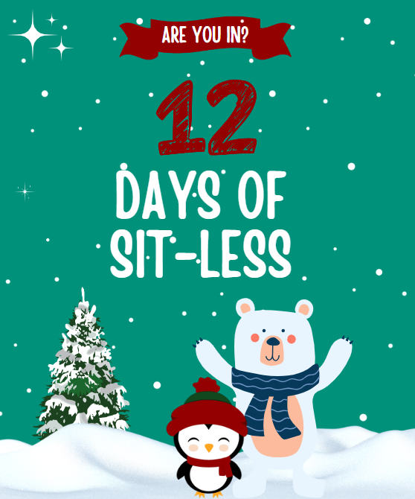
12 Days of Sit-Less Challenge
Workplace Toolkit
December 2023

What is the 12 Days of Sit Less Workplace Challenge All About?

TBDHU is challenging all workplaces in Thunder Bay and District to take part in our “12 Days of Sit Less” Challenge from December 4 – December 19! Each day during the challenge, we encourage you and your coworkers to participate in a different physical activity. These simple activities could be going for a walk, doing a wall sit, yoga, stretches, a scavenger hunt, and more! The schedule below outlines the activities for each day.

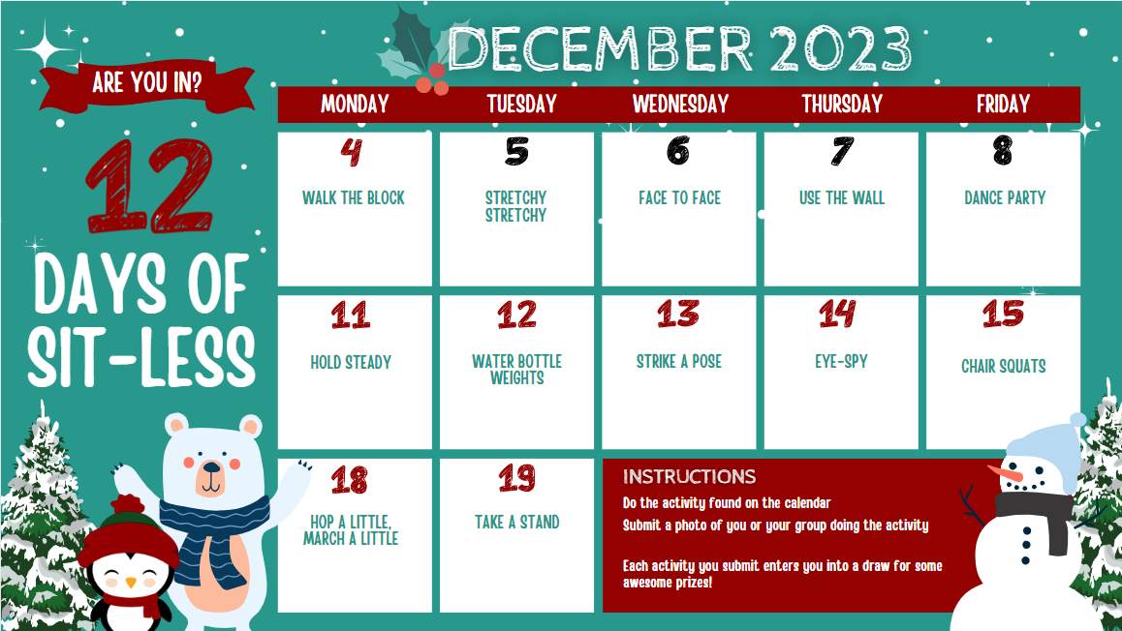

Keep track of the daily challenges that your workplace participates in and your organization will be entered into a draw to win a fantastic slow cooker with recipe book to make hearty soups and stews to share at work. The more days that your organization participates, the greater the chances of winning!

How it works:
- In the pages that follow are templates for each daily activity that you can simply copy/paste into an email and send out to your staff members. You can customize each email if you have ideas on how your coworkers can participate in the activity together.
- Invite employees at your worksite to join in. We encourage everyone to participate safely and only do the activities they can physically manage.
- Keep track of which activities your workplace participates in using the 12 Days of Sit Less calendar found at TBDHU.com/areyouin. Whether it’s only a few people or a larger group doing the activity, it counts for a ballot towards winning the grand prize.
- By 12:00 p.m. on December 21, 2023, submit your tracked activities on the activity tracking sheet at surveymonkey.com/r/12DaysofSitLess or email workplacewellness@tbdhu.com with a list of activities your workplace participated in. Later that day, TBDHU will draw a grand prize winning organization that will receive a handy slow cooker with a special recipe book designed for making workplace meals to share. The winning workplace must be located in the Thunder Bay District.

Good luck!

For more fun…
For an extra bit of fun, TBDHU is running the same 12 Days of Sit Less Challenge simultaneously for the public on our social media channels. By submitting photos on our Facebook or Instagram channels, your coworkers could also be eligible to be entered into a draw to win great prizes like a pair of snowshoes, ice cleats, Lakehead Regional Conservation Authority Explore Card parking passes, and more. Employees who participate at work could then also be eligible for these prizes if they post a photo. Full details of how the public challenge works are posted at tbdhu.com/areyouin

Are you in?
This initiative is part of TBDHU’s Are You In? campaign, under the theme of Sit Less Move More! This theme encourages adults to be more physically active and take breaks from being sedentary throughout the day, whether at work or at home. Learn more about the Are you in? campaign by visiting tbdhu.com/areyouin. You can also support the campaign by putting up Sit Less Move More posters in your building(s). Let us know how many you would like and we’ll get them over to you!

Contact us
If you would like posters or other resources to support employees to be more active, or if you have any questions about this 12 Days of Sit Less Challenge, please email workplacewellness@tbdhu.com.

Intro email

Hello Healthy Living Champions!

Thunder Bay District Health Unit is challenging all workplaces in Thunder Bay and District to take part in the “12 Days of Sit Less” Challenge from December 4–19! Each day during the challenge, our employees are encouraged to participate in a different physical activity. These simple activities could be going for a walk, a wall sit challenge, yoga, stretches, a scavenger hunt, and more! The more days that we participate, the greater the chances of winning a fantastic slow cooker with recipe book to make hearty soups and stews to share!

Are you in?
This initiative is part of TBDHU’s Are You In? campaign, under the theme of Sit Less Move More! It encourages adults to be more physically active and take breaks from being sedentary throughout the day, whether at work or at home. Learn more about the Are you in? campaign at tbdhu.com/areyouin.

For extra fun…
TBDHU is also running the same 12 Days of Sit Less Challenge simultaneously for the public on its Facebook and Instagram channels. By submitting photos of yourself participating in the daily activities, you could also be eligible to be entered into a draw to win great prizes like a pair of snowshoes, ice cleats, Lakehead Regional Conservation Authority Explore Card parking passes, and more. Full details of how the public challenge works are posted at tbdhu.com/areyouin.

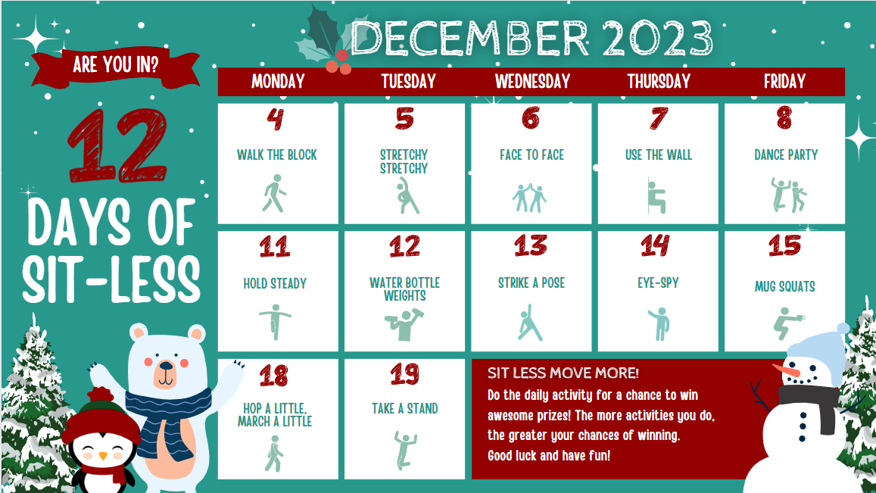
Feel free to use this header for your emails!

Day 1: Monday, December 4, 2023 Walk the Block

Today is the first day of the “12 Days of Sit Less” challenge!
The Thunder Bay District Health Unit has challenged us to be active at work for the next 12 days. Every day that we participate in this challenge, we have a chance to win great prizes.

The challenge – Walk the Block!
Today's challenge is to get outside and go for a walk down the street, around the block or on a
trail. Maybe a co-worker would like to join you!

Are you in?
Let’s meet at: [decide a meeting time and place] to go for a walk. If you can’t join the group, try to go for a walk on your own if you can today. Remember to participate safely and only do the activities you can physically manage.

You could win!
Post a picture of yourself participating in the daily challenge to the TBDHU Facebook and Instagram channels for more chances to win great prizes.

Did you know?
Adults are recommended to get at least 30 minutes of activity per day. You can accumulate your recommended daily physical activity minutes by taking a 15 minute walking break 2 times a day!

The “12 Days of Sit Less” Challenge is part of the Are you in? healthy lifestyle campaign. Learn more about it at TBDHU.com/areyouin.

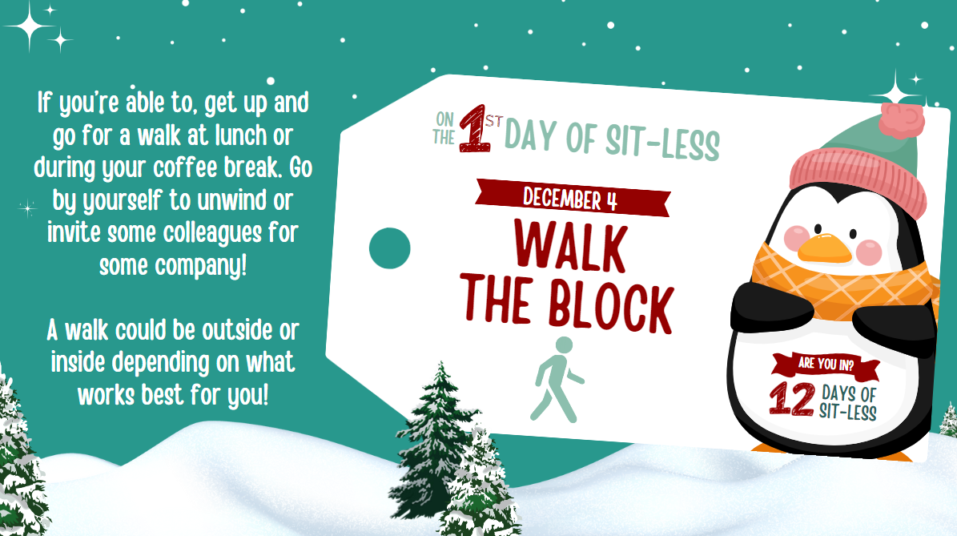

Day 2: Tuesday, December 5, 2023 Stretchy Stretchy

It’s day 2 of the “12 Days of Sit Less” Challenge!
The Challenge
Today’s challenge is “Stretchy Stretchy”. As the name suggests, we are challenged to take a break from sitting to do some full body stretches! Get up every hour to do a few minutes of stretching today.

Are you in?
Let’s meet at [decide a meeting time and place] and do some group stretches. If you can’t join the group or you’d rather do this on your own, that’s okay too. *Remember to participate safely and only do the activities you can physically manage.*
Did you know…
Since the 1970s, the amount of desk jobs (requiring little physical activity) has more than doubled! The majority of the current workforce is in administrative, desk or office roles. Lack of movement during the day can lead to muscle pain and strain. Getting up every hour to do a 5-10 minute stretch is recommended.

The “12 Days of Sit Less” Challenge is part of the Are you in? healthy lifestyle campaign. Learn more about it at TBDHU.com/areyouin.
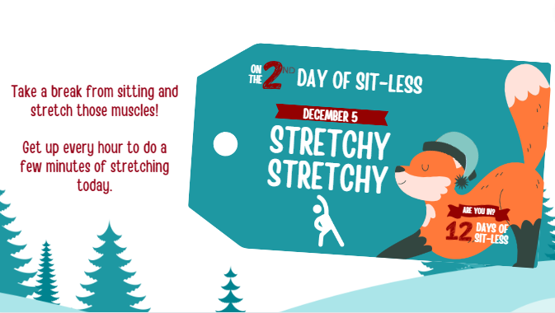

Day 3: Wednesday, December 6, 2023 Face to Face
Today is day 3 of the “12 Days of Sit Less” challenge!

The Challenge – Face to Face
Today’s challenge is about making an email or two more friendly by walking away from your screen and delivering the messages in person. The idea here is to break up the sitting time and to get up and moving. A face-to-face dialogue (ideally with both parties standing) may actually save time by going over details that would have taken several back and forth messages. Plus, positive and meaningful conversation can be helpful for mental health too.

Are you in?
Let’s try delivering an email or two in person during our work day today.

Did you know…
In Canada, adults, spend 9.6 hours of waking time being sedentary. The 24 hour movement guidelines recommend limiting sedentary time to 8 hours or less! You can achieve this by breaking up long periods of sitting to get up and stretch!

The “12 Days of Sit Less” Challenge is part of the Are you in? healthy lifestyle campaign. Learn more about it at TBDHU.com/areyouin.
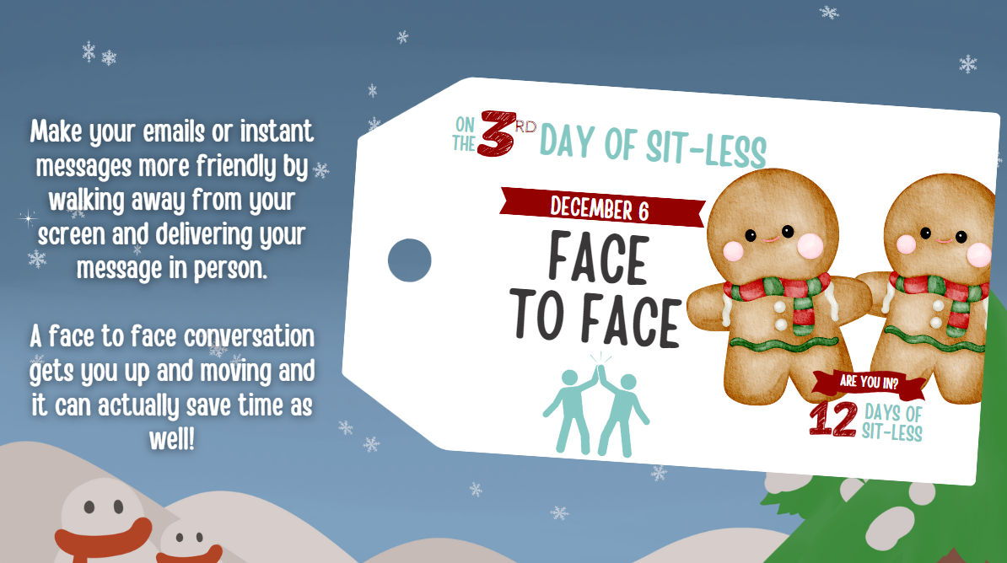

Day 4: Thursday, December 7, 2023 Use the Wall

It’s day 4 of the “12 Days of Sit Less” Challenge!
The Challenge – Use the Wall
The challenge is to take a break from sitting in your chairs and try “sitting” on the wall instead, followed by a few wall push-ups and wall-planks. What is a “wall sit” you ask? Lean against a wall with feet planted flat and firmly on the ground, shoulder-width apart. Feet should also be about two feet away from the wall (though the optimal distance will somewhat depend on a person's height). Slowly slide down the wall with your back pressed against it until legs are bent at a right angle. Knees should also be directly above the ankles and your back should touch the wall at all times. Depending on your strength, try holding the position for 20 seconds to a minute.

Are you in?
Let’s challenge each other to see how long we last doing a wall sit. *Remember to participate safely and only do the activities you can physically manage.*
Did you know…
In addition to 150 minutes of moderate-to-vigorous physical activity per week, adults should add in balance and muscle strengthening activities at least 2 times per week.

The “12 Days of Sit Less” Challenge is part of the Are you in? healthy lifestyle campaign. Learn more about it at TBDHU.com/areyouin.

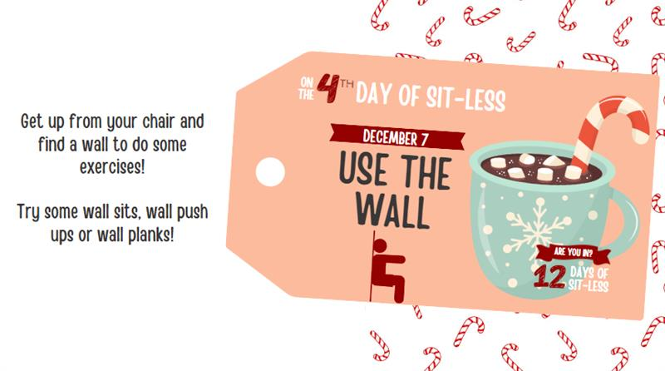

Day 5: Friday, December 8, 2023 Dance Party
Today is day 5 of the “12 Days of Sit Less” challenge!

The Challenge
Thank goodness it’s Friday! Let’s celebrate by turning up the tunes. Today’s challenge is to choose songs with a good beat and move to the music so you can feel your heart pumping!

Are you in?
Let’s meet at [decide a meeting time and place] to dance together. If you can’t join the group or you’d rather do this on your own, that’s okay too. *Remember to participate safely and only do the activities you can physically manage.
You could win!
Post a picture of yourself participating in the daily challenge to the TBDHU Facebook and Instagram channels for more chances to win great prizes.

Did you know…
Studies show though that people who take their breaks are more productive and have better mental health. Incorporating physical activity like dancing into your break releases endorphins and can make us feel happier.

The “12 Days of Sit Less” Challenge is part of the Are you in? healthy lifestyle campaign. Learn more about it at TBDHU.com/areyouin.
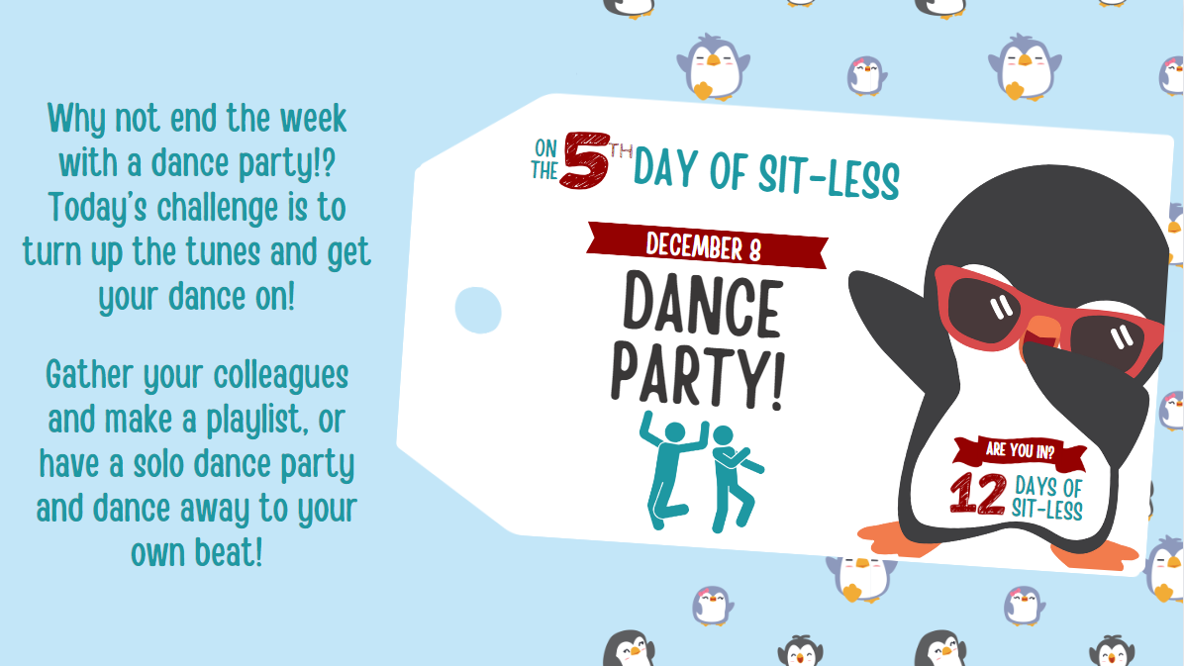

Day 6: Monday, December 11, 2023 Hold Steady

Today is day 6 of the “12 Days of Sit Less” challenge!

The Challenge – Hold Steady
Today’s challenge is to test your balance. Try some of these movements: stand on one leg, side/back leg raises, toe stands. Here’s a great resource to help you along: ottawapublichealth.ca/en/public-health-topics/strength-and-balance-exercises.aspx

Are you in?
Let’s meet at [decide a meeting time and place] to hold steady together. If you can’t join the group or you’d rather do this on your own, that’s okay too. *Remember to participate safely and only do the activities you can physically manage.
Did you know…
Strength and balance exercises are just as important as endurance activity. Strong muscles and improved balance make it easier to do daily activities and help to prevent falls.

The “12 Days of Sit Less” Challenge is part of the Are you in? healthy lifestyle campaign. Learn more about it at TBDHU.com/areyouin.

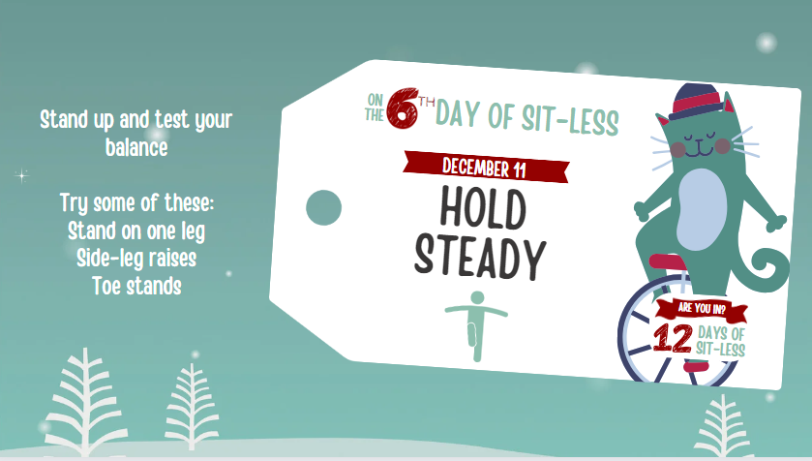

Day 7: Tuesday, December 12, 2023 Water bottle weights
Today is day 7 of the “12 Days of Sit Less” challenge!

The Challenge
We’re at the half-way point in the “12 Days of Sit Less” Challenge! The challenge of the day is to turn our regular old water bottles into workout weights. Using a full water bottle, do various exercises as you would use a dumbbell. You could do arm curls to strengthen muscles at the front and back of the arms, raise it above your shoulders, hold it out to the side, etc. Remember to switch sides and try to repetitions of 8-10. When you’re all done, pop the top and hydrate with that refreshing water!
Are you in?
Let’s meet at [decide a meeting time and place] to work out our water bottles together. If you can’t join the group or you’d rather do this on your own, that’s okay too. *Remember to participate safely and only do the activities you can physically manage.
Did you know…
Water is essential to life. Getting enough water every day is important for your health and is the best way to quench your thirst. Getting up regularly to fill your water bottle is one way to Sit Less and Move More!

The “12 Days of Sit Less” Challenge is part of the Are you in? healthy lifestyle campaign. Learn more about it at TBDHU.com/areyouin.

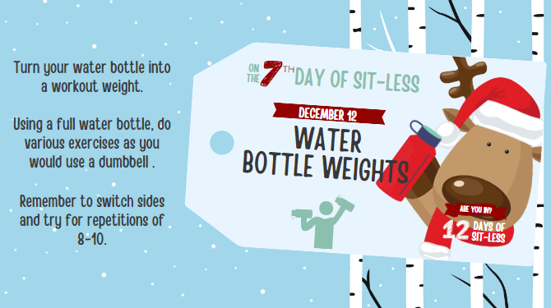

Day 8: Wednesday, December 13, 2023 Strike a Pose

Today is day 8 of the “12 Days of Sit Less” challenge!

We’re right in the groove of this 12 Days of Sit Less challenge! We hope you’re enjoying it as much as we are at TBDHU!

The Challenge
Today’s challenge is to get up out of your chair and “strike a pose”. Stretch your arms and your legs, or maybe even try a mini-yoga session. Here’s a quick yoga video to guide you through some gentle movements: youtube.com/watch?v=M-8FvC3GD8c

Are you in?
Let’s meet at [decide a meeting time and place] to participate in a yoga session! Remember to participate safely and only do the activities you can physically manage.

Did you know…
Did you know that it’s possible to be physically active and sedentary? Even if you exercise, it is still important to make sure you are not sitting most of the day. So strike a pose!

The “12 Days of Sit Less” Challenge is part of the Are you in? healthy lifestyle campaign. Learn more about it at TBDHU.com/areyouin.

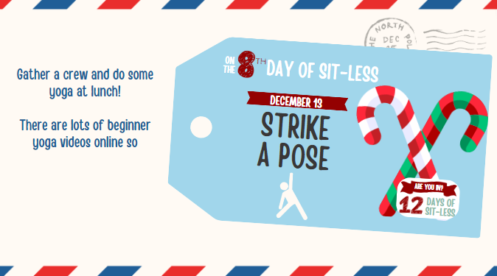

Day 9: Thursday, December 14, 2023 Eye Spy

Today is day 9 of the “12 Days of Sit Less” challenge!

The Challenge – Eye Spy
This challenge is a scavenger hunt. Leave your desk and see if you can find these 4 things.
- Something plaid
- Something that starts with the letter “E”
- Something round
- Something fluffy
The idea here is to have fun, be creative and move around. So, try to find these items in an area that is far from your workstation (like across the room, on another floor, outside, etc.).

Are you in?
Challenge a colleague to see who can find the most creative items.
Did you know…
Regular physical activity can also be an opportunity to meet new people and connect with friends – both of which help prevent cognitive decline and keep our brains healthy.

The “12 Days of Sit Less” Challenge is part of the Are you in? healthy lifestyle campaign. Learn more about it at TBDHU.com/areyouin.

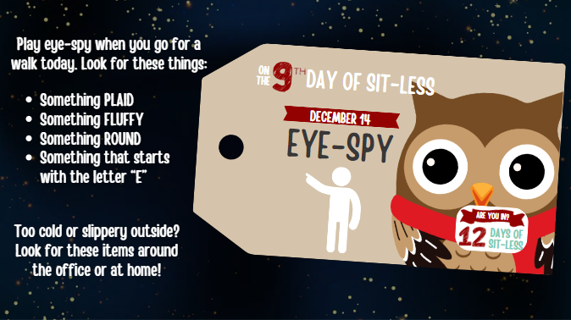

Day 10: Friday, December 15, 2023 Mug Squats

Today is day 10 of the “12 Days of Sit Less” challenge!

The Challenge – Mug Squats
The challenge of the day is to turn our beloved coffee mugs into workout props. Before you refill your mug at coffee time..(it’s best to do this with an empty mug to avoid any unwanted spills)…try some of these squats:
- Hold mug with 2 hands out in front of you.
- Standing tall with your feet directly under your hips, put your shoulders back and tighten your stomach muscles.
- Bend down, keeping your upper body as straight as you can. Pretend like you’re lowering down to sit in a chair. Keep your knees above your toes.
- Straighten your legs, but be careful not to lock your knees once you get back up.
- Aim for 3 sets of 10 to 15 squats. Try switching the mug from one hand to another each time you squat for an extra challenge !
- For variation, try the same squat as above, but this time with arms bent and holding the mug close to your chest.

Are you in?
Let’s meet at [decide a meeting time and place] and try some mug squats together. If you can’t join the group or you’d rather do this on your own, that’s okay too. *Remember to participate safely and only do the activities you can physically manage.
Did you know…
Health benefits of balance and muscle-strengthening activities (like squats) include increased muscle mass and bone density, improved cardio metabolic and physical functioning, reduced musculoskeletal symptoms and reduced symptoms of anxiety and depression.

The “12 Days of Sit Less” Challenge is part of the Are you in? healthy lifestyle campaign. Learn more about it at TBDHU.com/areyouin.

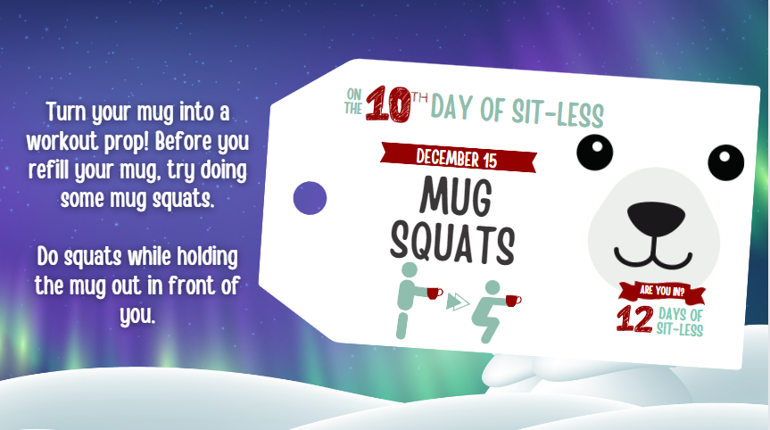

Day 11: Monday, December 18, 2023 Hop a Little, March a Little

Today is day 11 of the “12 Days of Sit Less” challenge!

The Challenge – Hop a little, march a little.
This challenge has you march or hop on the spot to music. Try to keep up the beat for a whole verse. You can increase the intensity by hopping on one leg at a time and then switching legs.

Are you in?
Let’s meet at [decide a meeting time and place] and do it together. If you can’t join the group or you’d rather do this on your own, that’s okay too. *Remember to participate safely and only do the activities you can physically manage.
Did you know…
There’s a strong connection between physical activity and mental health. Building activity into your day can help relieve stress, improve concentration and boost your overall mood

The “12 Days of Sit Less” Challenge is part of the Are you in? healthy lifestyle campaign. Learn more about it at TBDHU.com/areyouin.

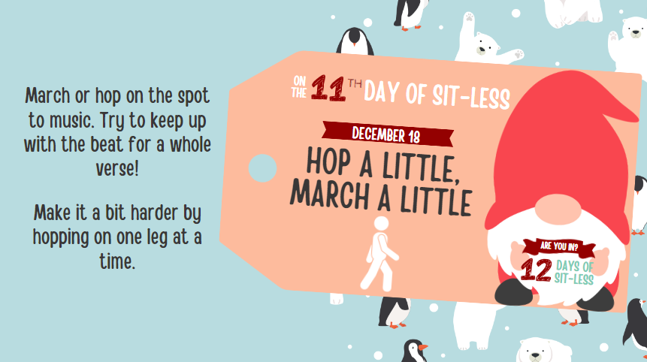

Day 12: Tuesday, December 19, 2023 Take a Stand

Today is day 12 of the “12 Days of Sit Less” challenge!

Congratulations! It’s the last day of this challenge and we hope the activities over the last two weeks have inspired you to sit less and move more often!

The Challenge
Hooray!! We made it to the last day of the “12 Days of Sit Less” Challenge!

Today’s challenge is a walking or standing meeting! The idea here is to go for a walk or stay standing during a meeting or a conversation where you would normally be sitting down. Under“stand”ably, it may be hard to stand during a long meeting. So, it’s okay to sit down if your legs get tired after a while. If you don’t have any meetings scheduled today, you could stand as you’re talking on the phone. Do what works best in your situation.

Are you in?
Lets try standing or walking more during the day today.

Did you know…
Simple, low-intensity activities such as standing, done intermittently throughout the day, is just as beneficial to your health as structured exercise! Canadian 24-Hour movement guidelines recommend several hours of light physical activity such as standing.
The “12 Days of Sit Less” Challenge is part of the Are you in? healthy lifestyle campaign. Learn more about it at TBDHU.com/areyouin.

